**4. ReactJS-HOL**

**Output**

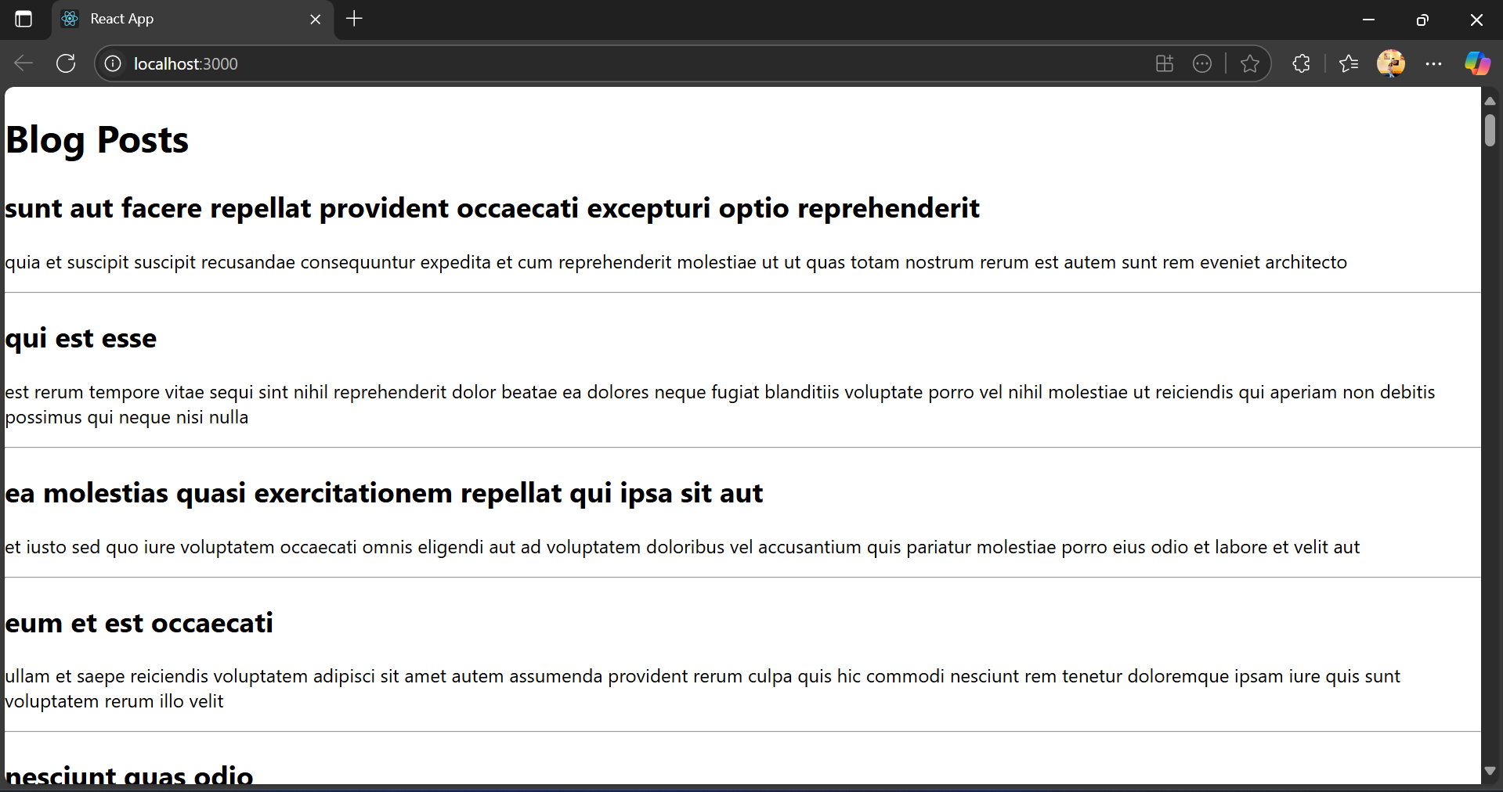

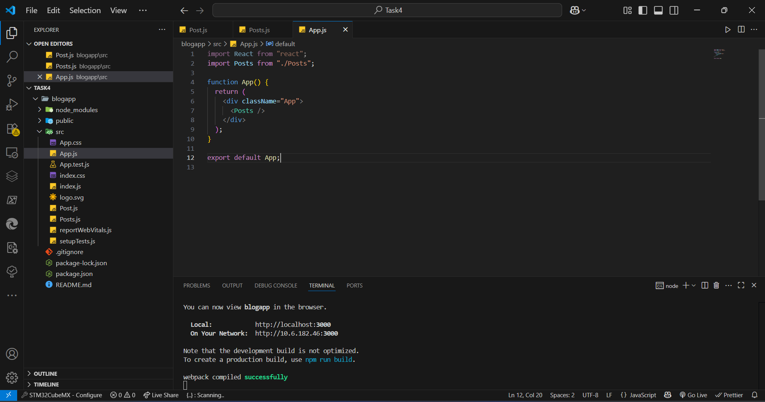

**App.js**

import React from "react";

import Posts from "./Posts";

function App() {

return (

<div className="App">

<Posts />

</div>

);

}

export default App;

**Post.js**

class Post {

constructor(id, title, body) {

this.id = id;

this.title = title;

this.body = body;

}

}

export default Post;

**Posts.js**

import React from "react";

import Post from "./Post";

class Posts extends React.Component {

constructor(props) {

super(props);

this.state = {

posts: [],

hasError: false,

};

}

loadPosts() {

fetch("https://jsonplaceholder.typicode.com/posts")

.then((res) => res.json())

.then((data) => {

const postList = data.map(

(post) => new Post(post.id, post.title, post.body)

);

this.setState({ posts: postList });

})

.catch((error) => {

this.setState({ hasError: true });

});

}

componentDidMount() {

this.loadPosts();

}

componentDidCatch(error, info) {

alert("An error occurred: " + error);

}

render() {

if (this.state.hasError) {

return <h2>Error loading posts.</h2>;

}

return (

<div>

<h1>Blog Posts</h1>

{this.state.posts.map((post) => (

<div key={post.id}>

<h2>{post.title}</h2>

<p>{post.body}</p>

<hr />

</div>

))}

</div>

);

}

}

export default Posts;